Prepositions of Place/Position

🔹 What Are Prepositions of Place/Position?
# Source: AI Source: Provided by: [Data Path: Persons Table -> ID Column: 1, Name_En Column: Motasem Essam] -> From: [Chatgpt (GPT-4-turbo)] on [7/28/2025]
Prepositions of place (or position) show the location or position of something or someone in space, often in relation to another object.
They answer the question: Where?

✅ Common Prepositions of Place
# Source: AI Source: Provided by: [Data Path: Persons Table -> ID Column: 1, Name_En Column: Motasem Essam] -> From: [Chatgpt (GPT-4-turbo)] on [7/28/2025]
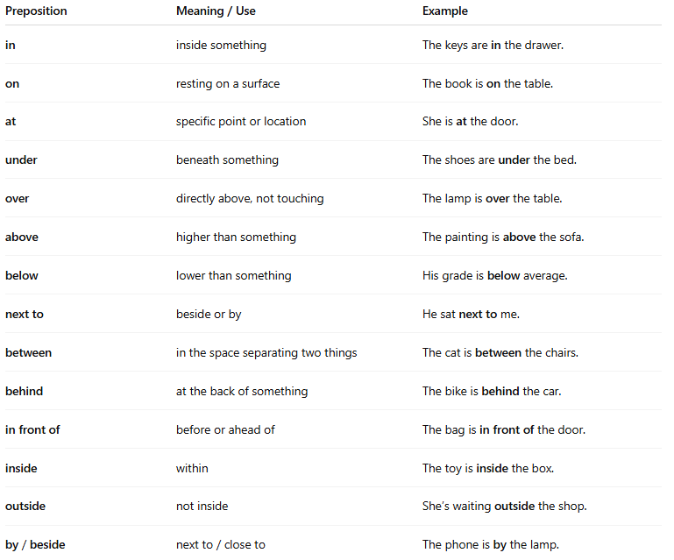
Preposition | Meaning / Use | Example
in | inside something | The keys are in the drawer.
on | resting on a surface | The book is on the table.
at | specific point or location | She is at the door.
under | beneath something | The shoes are under the bed.
over | directly above, not touching | The lamp is over the table.
above | higher than something | The painting is above the sofa.
below | lower than something | His grade is below average.
next to | beside or by | He sat next to me.
between | in the space separating two things | The cat is between the chairs.
behind | at the back of something | The bike is behind the car.
in front of | before or ahead of | The bag is in front of the door.
inside | within | The toy is inside the box.
outside | not inside | She’s waiting outside the shop.
by / beside | next to / close to | The phone is by the lamp.

🧠 Key Notes
# Source: AI Source: Provided by: [Data Path: Persons Table -> ID Column: 1, Name_En Column: Motasem Essam] -> From: [Chatgpt (GPT-4-turbo)] on [7/28/2025]
- "At" is used for specific points:
→ She’s at the station.
- "In" is used when something is inside an enclosed space:
→ The milk is in the fridge.
- "On" is used for surfaces:
→ The notebook is on the table.

